**Lab – 30**

**Student Name: Navneet P**

**Student ID: AF0411619**

***Sci-Py Transform and Interpolation***

Function and modules/submodules used:

1. **Scipy.interpolate**:  this sub-module contains spline functions and classes, 1-D and multidimensional (univariate and multivariate) interpolation classes, Lagrange and Taylor polynomial interpolators, and wrappers for [FITPACK](http://www.netlib.org/dierckx/) and DFITPACK functions.
2. **Interp1d:** interp1d is a function in SciPy used for one-dimensional interpolation. It's a part of the scipy.interpolate module. This function creates an interpolation object that can be used to interpolate values for points that fall between the given data points.

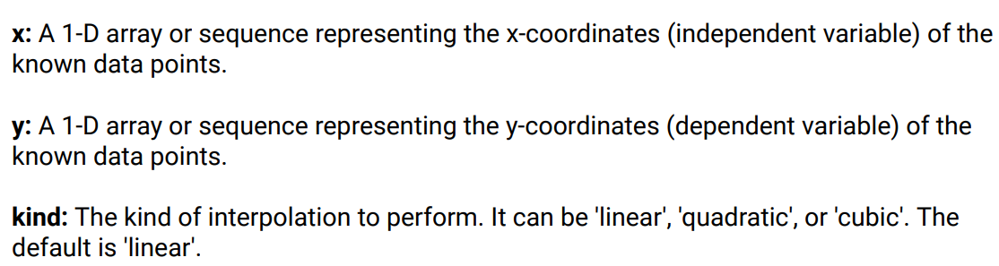

1. **Plt.text**: used to add data labels to the points on the graph

Q1. You are given the temperatures of 10 days but the 5th Day’s temperature is not known, using the interpolation function in scipy, calculate the value of Day 5th Temperature.

Solution:

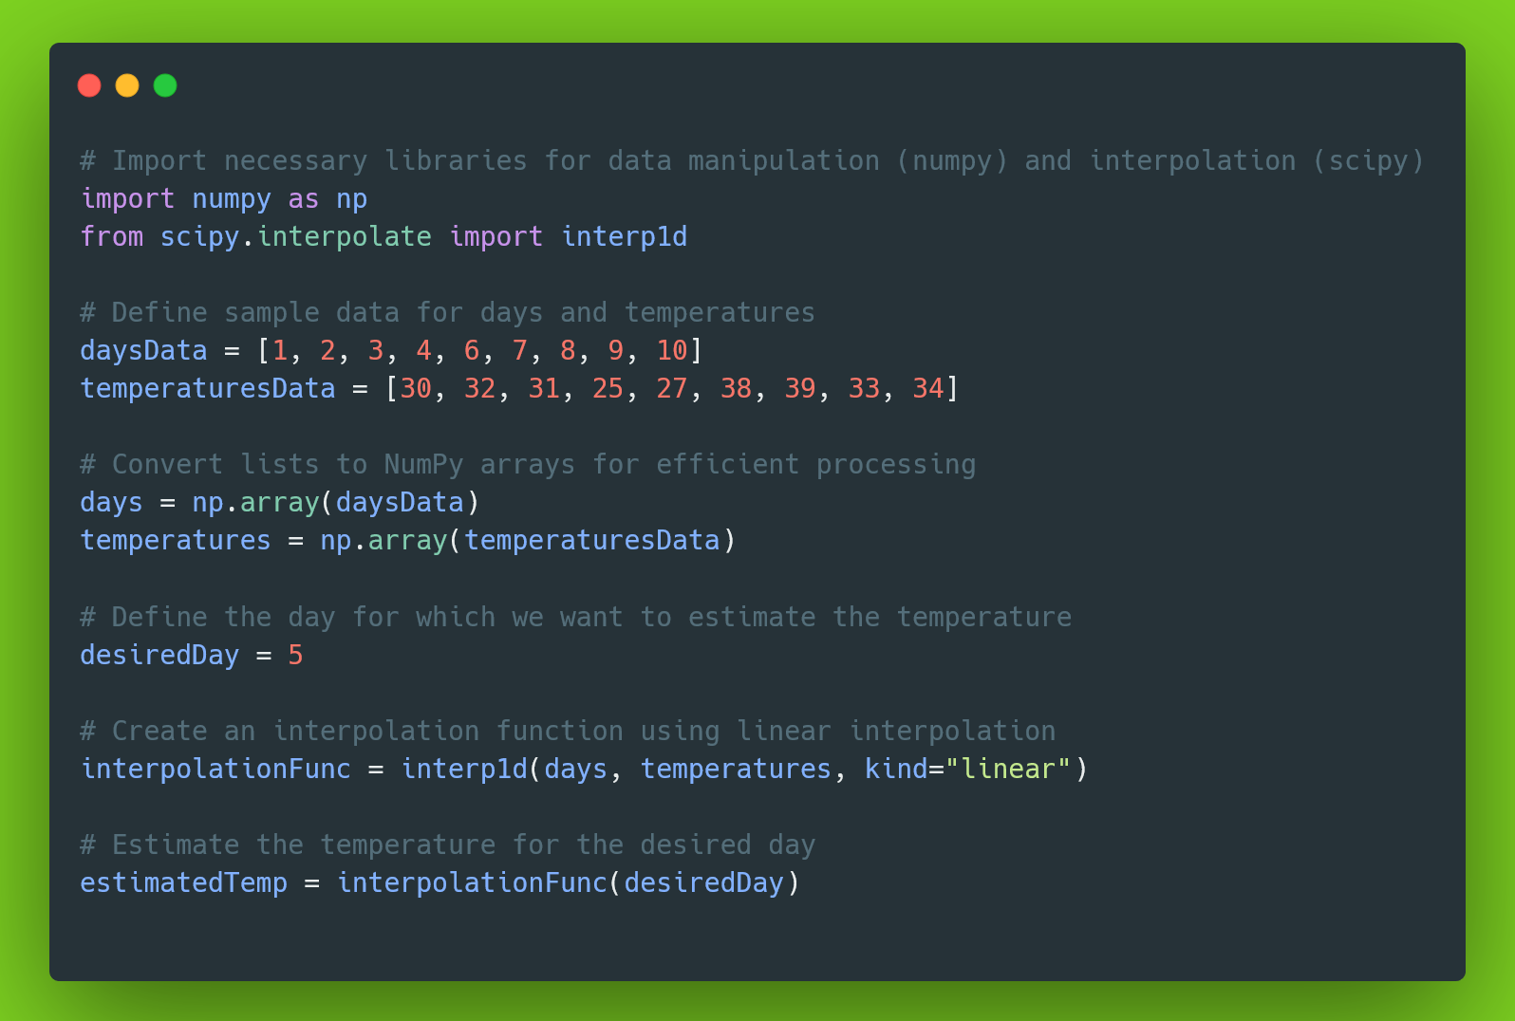

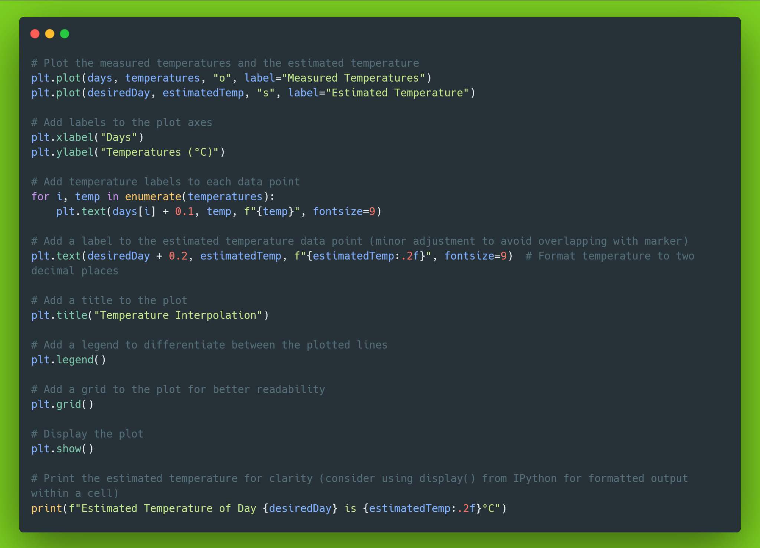

Output:

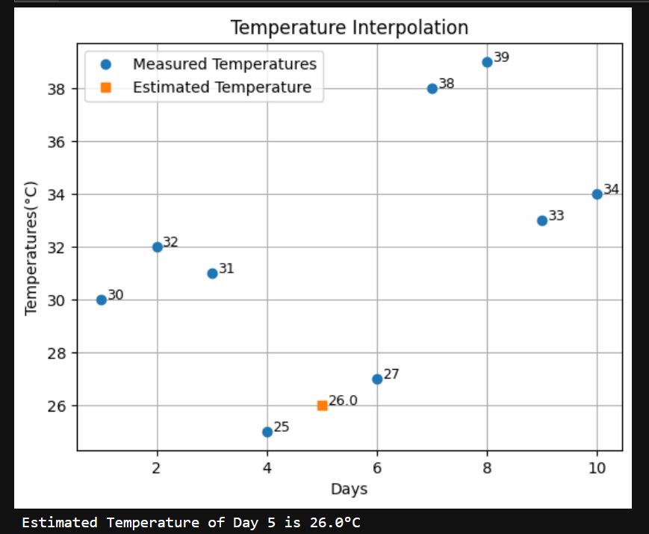

Q2. Interpolation question using a larger dataset.

Solution:

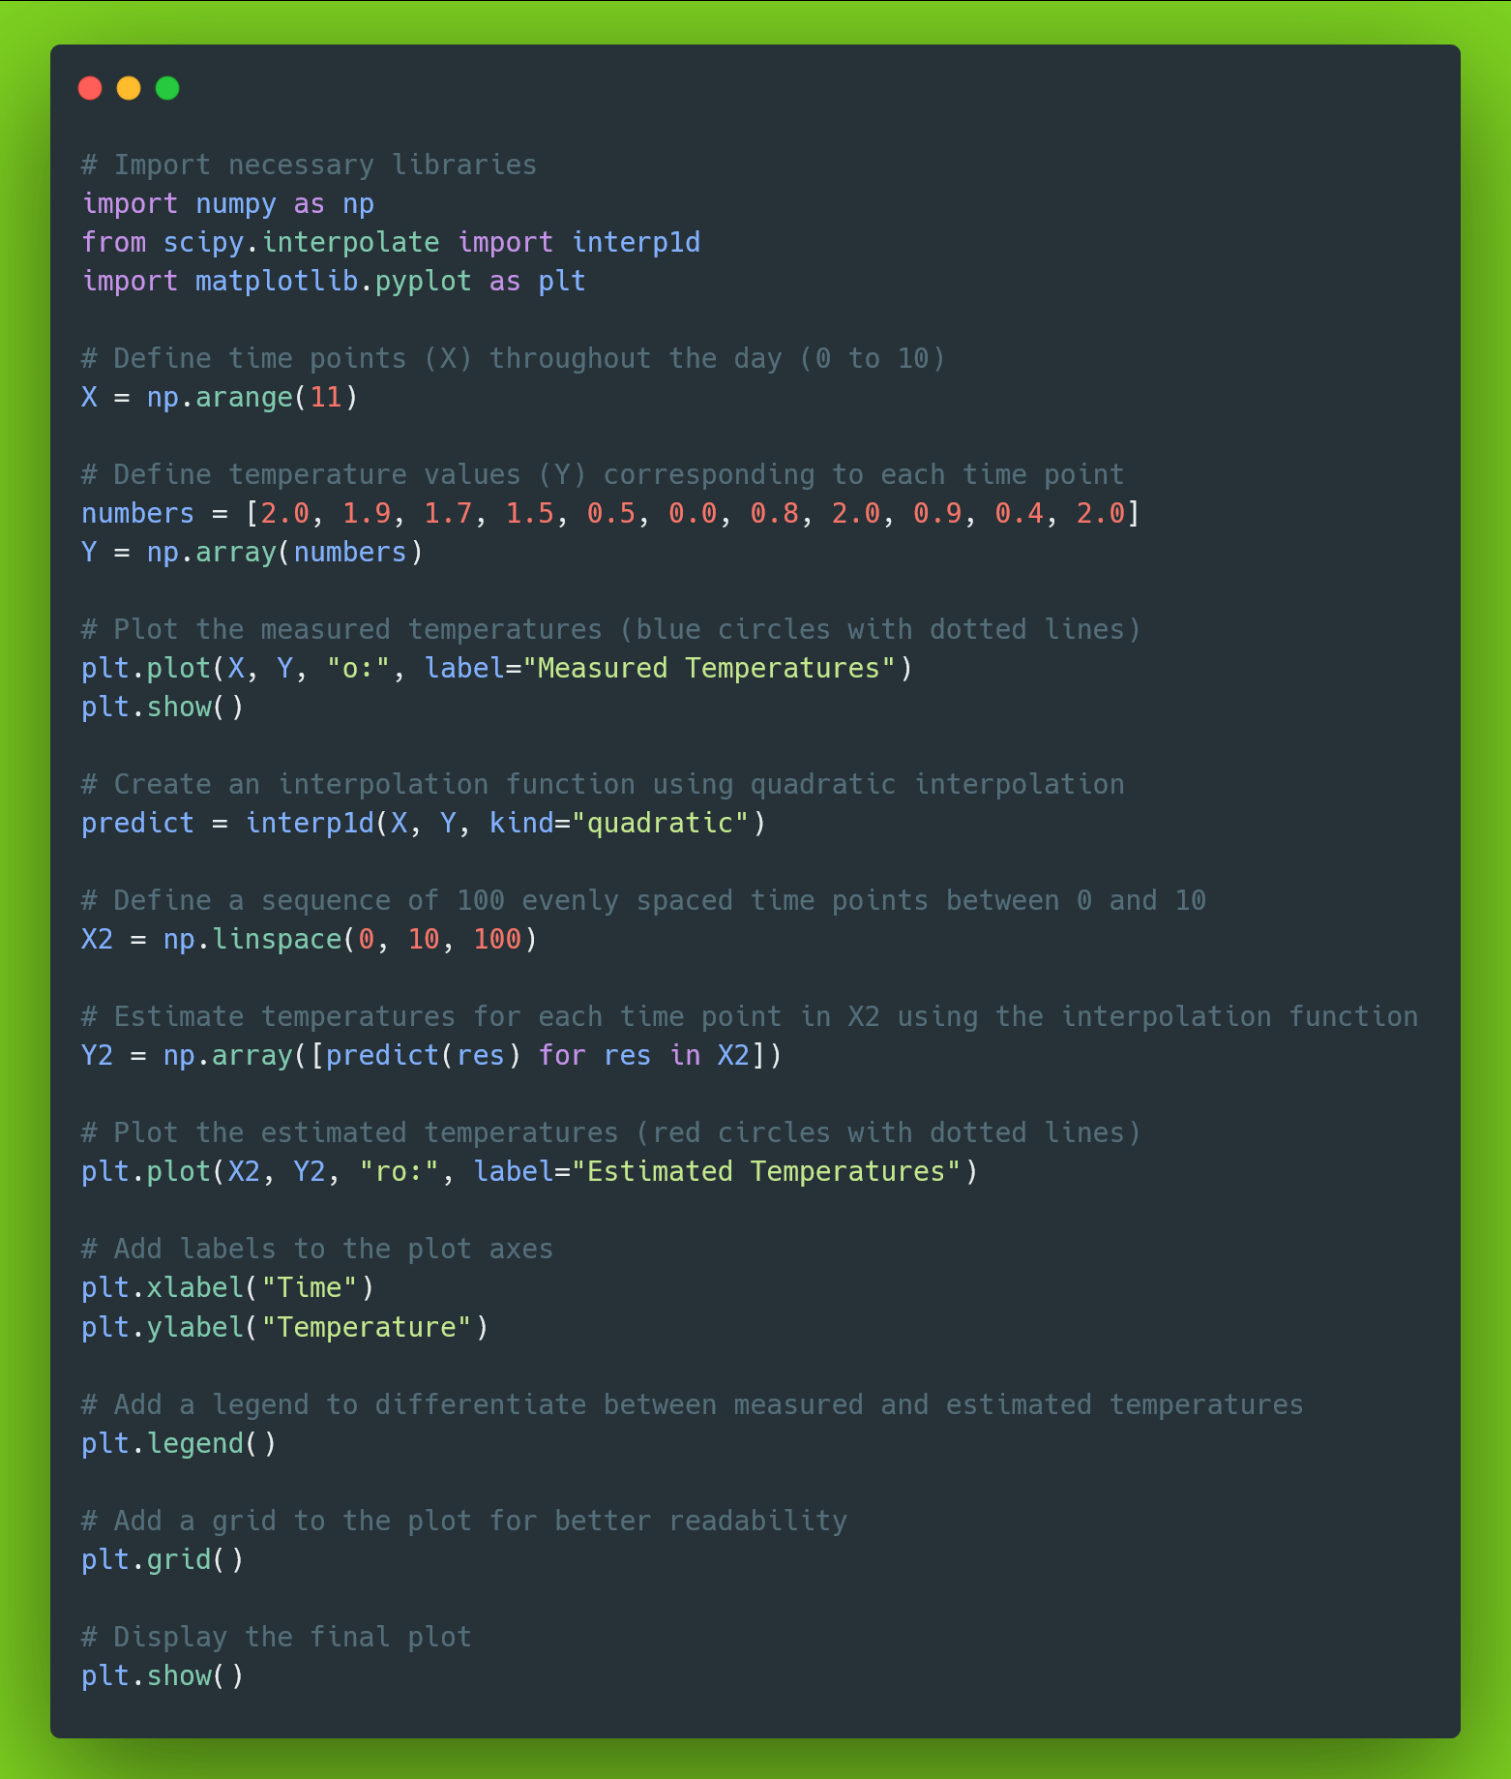

Output:

